

JAVA PROJECT REPORT ON
Library Book Borrowing, Return and Fine Calculation System

Submitted by
MANGALESH M
25BIT031

Under the Guidance of
DHILEEBAN A
Technical Trainer
Technical Department, KG College of Arts and Science

Academic Year: 2025 – 2026
APRIL 2026
Semester: I

DECLARATION
I hereby declare that the project entitled “Library Book Borrowing, Return and Fine Calculation System” submitted in partial fulfillment of the requirements for the course [Java Programming ] is a record of my original work carried out under the guidance of DHILEEBAN A , Technical Trainer, Technical Department, KG College of Arts and Science.
I further declare that this project has not been submitted previously, either in part or in full, for the award of any degree, diploma, or other similar title, at this or any other institution.
I have acknowledged all sources of information used in this project wherever applicable.

April 2026
Coimbatore

________________________
MANGALESH M

CERTIFICATE
This is to certify that the project entitled “Library Book Borrowing, Return and Fine Calculation System” is a bona fide work carried out by MANGALESH M , B.Sc IT I-’A’ Information Technology, KG College of Arts & Science, in partial fulfillment of the requirements for the course [Java Programming].
This project has been completed under my supervision and guidance during the academic period April 2026.

Place: Coimbatore
Date:09.04.2026

Submitted for the Viva-Voce Examination held on __________________________________

Guide: Head of the Department
(Technical Trainer, KGCAS) (Technical Head, KGCAS)
______________________ _______________________

TABLE OF CONTENTS
S. No. | Topics | Page. No.
1 | Introduction
1.1 | Objective
1.2 | Overview
1.3 | Features
2 | Program Analysis
2.1 | Problem Definition
2.2 | Project Overview
2.3 | Scopes and Limitations
3 | System Design
3.1 | Modules
4 | Methodology
4.1 | Problem Analysis
4.2 | System Design
4.3 | Program Development
4.4 | Testing and Validation
4.5 | Result and Documentation
4.6 | Algorithm
4.7 | Flowchart
5 | Source Code
6 | Input and Output Screens
7 | Discussion and Conclusion
7.1 | Discussion
7.2 | Conclusion
8 | References

ABSTRACT
The Library Book Borrowing, Return and Fine Calculation System is a console-based application developed using the Java programming language to automate the process of issuing and returning books in a library environment. In many educational institutions and small libraries, book issuing and returning activities are handled manually, which increases the chances of errors and delays in maintaining records.
This project provides a simple and efficient solution where users can borrow books by entering their name, book title, and borrowing duration. When the book is returned, the system checks whether the return is delayed and calculates the fine automatically based on the number of extra days.
The system is implemented using core Java concepts such as classes, objects, methods, loops, switch statements, and conditional statements. The application provides a menu-driven interface that allows users to perform operations easily.
The main objective of this system is to reduce manual work, improve accuracy, and demonstrate the practical implementation of object-oriented programming concepts in Java.

- INTRODUCTION
Libraries are essential parts of educational institutions because they provide access to academic books and reference materials required by students and faculty members. Managing library operations manually becomes difficult when the number of books and users increases.
Traditional library systems maintain records using notebooks or registers. This manual method consumes more time and may lead to errors such as incorrect fine calculation, missing records, and difficulty tracking borrowed books.
To overcome these issues, a computerized system is necessary. The Library Book Borrowing, Return and Fine Calculation System helps automate library operations by allowing users to borrow books, return books, and calculate fines automatically if the books are returned after the due date.
This system improves efficiency, accuracy, and speed of library management. It also helps students understand how Java programming can be used to develop real-world applications.

1.1 Objective
The main objectives of this project are:
• To design a simple library borrowing system using Java
• To automate the book borrowing process
• To automate the book return process
• To calculate late return fine automatically
• To reduce manual calculation errors
• To provide a user-friendly menu-driven system
• To demonstrate object-oriented programming concepts
• To improve efficiency in managing library operation

1.2 Overview
The system is developed as a menu-driven console application using Java. It allows the user to interact with the system through different options displayed on the screen.
The user can select operations such as:
- Borrow Book
- Return Book
- Exit System
During borrowing, the system collects:
- Student name
- Book name
- Borrowing duration
During returning, the system:
- Accepts return duration
- Compares borrowing duration
- Calculates fine if delayed
The system ensures that library transactions are handled quickly and accurately.

1.3 Features
Main features of the system include:

Borrow Book Feature
Allows users to enter student details and book details before issuing the book.

Return Book Feature
Allows users to return borrowed books by entering return duration.

Automatic Fine Calculation Feature
Calculates fine automatically if the return exceeds allowed borrowing days.
Example:
If borrowing days = 5
Return days = 7
Fine = 2 × 5 = Rs.10

Menu-Driven Interface
Displays simple options for easy interaction.

Error Reduction
Minimizes manual mistakes during calculations.

- PROGRAM ANALYSIS
Manual library management systems create several difficulties such as:
• Maintaining borrowing records manually
• Difficulty tracking return dates
• Errors in calculating fines
• Increased paperwork
• Time-consuming operations
Because of these problems, an automated system is necessary to improve efficiency and accuracy.
The proposed system solves these problems by providing an automated borrowing and returning process.

2.1 Problem Definition
Manual library management systems create several difficulties such as:
• Maintaining borrowing records manually
• Difficulty tracking return dates
• Errors in calculating fines
• Increased paperwork
• Time-consuming operations
Because of these problems, an automated system is necessary to improve efficiency and accuracy.
The proposed system solves these problems by providing an automated borrowing and returning process
2.2 Project Overview
The system is developed using Java programming language and performs basic library operations through a console interface.
The system performs the following tasks:
Accepts student name
Accepts book name
Stores borrowing duration
Accepts returning duration
Calculates fine automatically
This project demonstrates how object-oriented programming can be used to develop simple real-world applications

2.3 Scopes and Limitations
Scope
The system can be used in:
• School libraries
• College libraries
• Tuition centers
• Training institutes
Functions supported:
Borrow book
Return book
Calculate fine

Limitations
Current system limitations include:
Supports only one book at a time
No database connectivity
Console-based interface only
No record storage facility

Future Enhancements
System can be improved by adding:
Database storage
Multiple book handling
Graphical user interface
Student ID tracking
Automatic due date calculation

- SYSTEM DESIGN
System design describes how the system is structured into modules.

3.1 MODULES (Detailed Explanation)

Module 1: Borrow Book Module
This module collects information from users.
Inputs:
Student name
Book name
Borrow days
Example:
Enter Student Name
Enter Book Name
Enter Borrow Days
Output:
Book Borrowed Successfully

Module 2: Return Book Module
This module collects return duration from user.
Input:
Return days
Example:
Enter Number of Days Taken to Return Book
Output:
Book Returned Successfully

Module 3: Fine Calculation Module
This module compares borrow days and return days.
If delayed:
Fine calculated using formula:
Fine = (Return Days − Borrow Days) × 5
Otherwise:
Fine = 0

Module 4: Exit Module
Terminates program execution safely.

- METHODOLOGY
4.1. Problem Analysis
Manual library operations require more time and effort. Therefore, automation improves system efficiency and reduces calculation errors.
4.2. System Design
System structure includes:
LibrarySystem class
LibraryMain class
Methods used:
borrowBook()
returnBook()
4.3. Program Development
The program is developed using Core Java concepts such as:
Classes
Objects
Scanner class
Methods
Switch statement
Conditional statements
Example:

if(returnDays > borrowDays)

Used for checking delay condition.
Example:

switch(choice)

Used for menu selection..
4.4. Testing and Validation

Test Case | Input | Expected Output
Borrow book | Enter student name | Book borrowed successfully
Return book early | Return ≤ borrow days | No fine
Return book late | Return > borrow days | Fine calculated
Exit option | Press 3 | Program terminated

4.5. Result and Documentation
The system was tested successfully with different input values.
Results show:
Borrow operation works correctly
Return operation works correctly
Fine calculation works correctly
The documentation explains system structure and implementation clearly
4.6. Algorithm
Step 1: Start program
Step 2: Display menu options
Step 3: Accept user choice
Step 4: If choice = Borrow Book
→ Enter student name
→ Enter book name
→ Enter borrow days
Step 5: If choice = Return Book
→ Enter return days
Step 6: Compare return days with borrow days
Step 7: If delayed
→ Calculate fine
Step 8: Display fine amount
Step 9: Repeat process until exit selected
Step 10: Stop program
4.7. Flowchart
Students should draw a flowchart showing program flow.
Example flow:
Start
↓
Display Menu
↓
Enter Choice
↓
Borrow Book
↓
Return Book
↓
Check Delay
↓
Calculate Fine
↓
Display Fine
↓
Exit
- SOURCE CODE

import java.util.Scanner;

class LibrarySystem {

String bookName;
String studentName;
int borrowDays;
int fine = 0;

void borrowBook() {
Scanner sc = new Scanner(System.in);

System.out.println("Enter Student Name:");
studentName = sc.nextLine();

System.out.println("Enter Book Name:");
bookName = sc.nextLine();

System.out.println("Enter Number of Days to Borrow:");
borrowDays = sc.nextInt();

System.out.println("Book Borrowed Successfully!");
}

void returnBook() {
Scanner sc = new Scanner(System.in);

int returnDays;

System.out.println("Enter Number of Days Taken to Return Book:");
returnDays = sc.nextInt();

if (returnDays > borrowDays) {
fine = (returnDays - borrowDays) * 5;
} else {
fine = 0;
}

System.out.println("Book Returned Successfully!");
System.out.println("Fine Amount = Rs. " + fine);
}
}

public class LibraryMain {

public static void main(String[] args) {

Scanner sc = new Scanner(System.in);
LibrarySystem lib = new LibrarySystem();

int choice;

do {
System.out.println("\n--- Library Menu ---");
System.out.println("1. Borrow Book");
System.out.println("2. Return Book");
System.out.println("3. Exit");

System.out.println("Enter your choice:");
choice = sc.nextInt();

switch (choice) {

case 1:
lib.borrowBook();
break;

case 2:
lib.returnBook();
break;

case 3:
System.out.println("Thank you for using Library System");
break;

default:
System.out.println("Invalid Choice");
}

} while (choice != 3);

}
}

- INPUT AND OUTPUT SCREENS
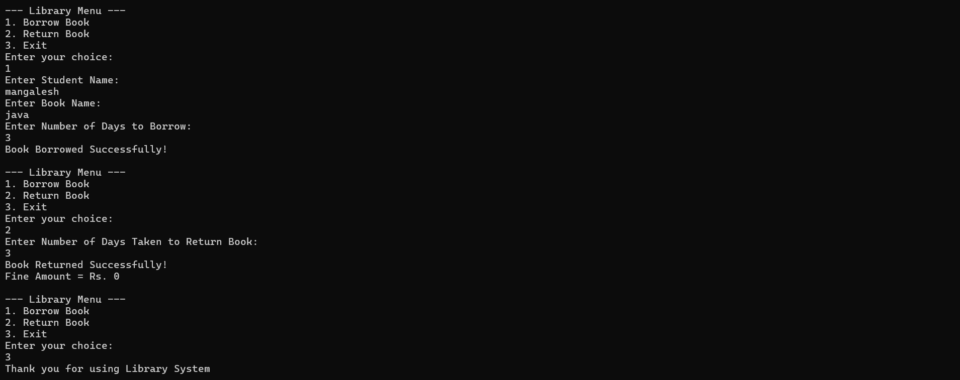

- DISCUSSION & CONCLUSION

7.1 Discussion
The system successfully performs borrowing and returning operations using a menu-driven interface. It calculates fine automatically based on delay duration.
The project demonstrates the use of object-oriented programming concepts such as classes and methods effectively.
Testing results show that the system works correctly under different conditions.

7.2 Conclusion
The Library Book Borrowing, Return and Fine Calculation System is successfully developed using Java programming language.
The system:
Reduces manual workload
Improves calculation accuracy
Provides faster operations
Demonstrates practical Java concepts
Future improvements can include database connectivity and graphical interface support
- REFERENCES

The following resources were used during the development of this project:
Books

Books
- Java: The Complete Reference
Herbert Schildt, Java: The Complete Reference, McGraw-Hill Education.
- Programming with Java
E. Balagurusamy, Programming with Java, McGraw-Hill Education.
- Core Java Volume I – Fundamentals
Cay S. Horstmann, Core Java Volume I – Fundamentals, Prentice Hall.
- Head First Java
Kathy Sierra and Bert Bates, Head First Java, O’Reilly Media.

Websites
- Oracle Java Documentation
https://www.oracle.com/java
- GeeksforGeeks
https://www.geeksforgeeks.org
- Javatpoint
https://www.javatpoint.com
- W3Schools
https://www.w3schools.com/java

